In a job interview focused on Android development with Jetpack Compose, interviewers often test your understanding of Compose's fundamentals, your ability to create responsive and interactive UI components, and your overall problem-solving skills. Here are some scenarios and questions you might encounter:

1. **Building a Simple UI Component**:
   * Create a simple Compose UI that includes a TextField, Button, and a Text component that displays the content entered in the TextField when the Button is clicked.
2. **Layouts and Modifiers**:
   * Use Compose layout components like **Row**, **Column**, or **Box** to organize elements. Discuss how to use Modifiers to apply padding, alignment, or click events.
3. **Dynamic Lists with LazyColumn**:
   * Implement a basic list using **LazyColumn** and discuss how you might use **items** or **item** to populate it. You might be asked to handle data changes or manage state in a list item.
4. **Managing State in Compose**:
   * Explain the role of **remember** and **mutableStateOf**, and demonstrate how you'd use state in Compose to update the UI. Interviewers might ask you to manage state across multiple components.
5. **Reusable Components and Functions**:
   * Create a reusable Compose component, like a custom button or card. Interviewers could ask about best practices for designing reusable components.
6. **Handling Navigation with Compose**:
   * Discuss how you would implement navigation using Jetpack Navigation for Compose. Interviewers might ask about passing arguments between screens and managing the back stack.
7. **Using ViewModels with Compose**:
   * Explain how to integrate a ViewModel with Compose. You might be asked to show how to share state between Compose and ViewModel and handle lifecycle-aware components.
8. **Theming and Styling in Compose**:
   * Create a simple theme or apply styling to Compose components. Discuss how to define colors, typography, and shapes, and apply them consistently.
9. **Animations and Transitions**:
   * Describe how to create animations in Compose using **animateFloat**, **animateDp**, or other animation APIs. You might be asked to create simple transitions or use animated visibility.
10. **Testing Compose Components**:
    * Explain how you'd write tests for Compose components. Interviewers might ask about unit tests and integration tests with Compose and how to use **ComposeTestRule** to simulate user interactions.

To prepare, focus on building small projects with Compose, experimenting with different UI elements, managing state, and incorporating navigation. Also, be ready to discuss your approach to architecture and best practices in Compose development.

**Jetpack compose**

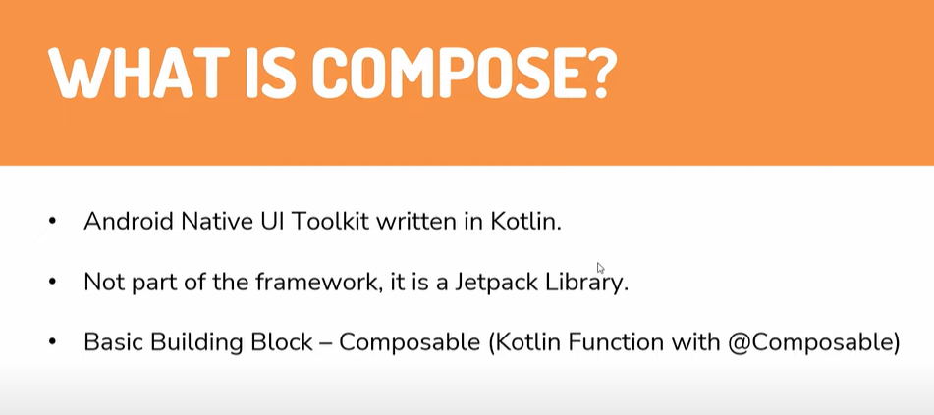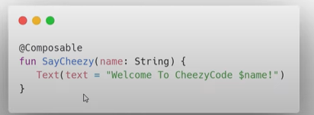

Vaise hum views use krte the or views ki madad se ui create krte the pr yahan hum composable functions use krenge jaise Text ek composable function hai aise e hmare pass kafi composable functions hai jaise ki buttonrow, column vgera vgera

Compose mein kya hota hai ki aap mujhe data do mein tumhe UI doonga

So we make composable function and gave that function something

It will make UI accordingly

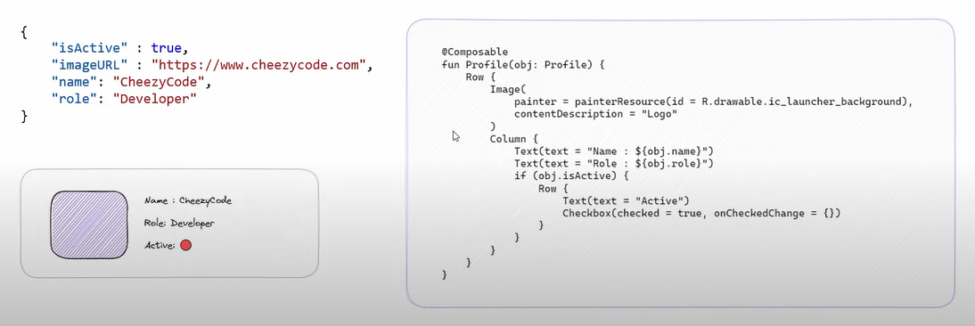

So there are lot of changes if we compare gradle file like we got compose dependencies, buildFeature{

Compose = true}

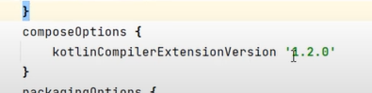

Need one compose c ompiler as well

Now compiler ka version hai 1.2.0 and

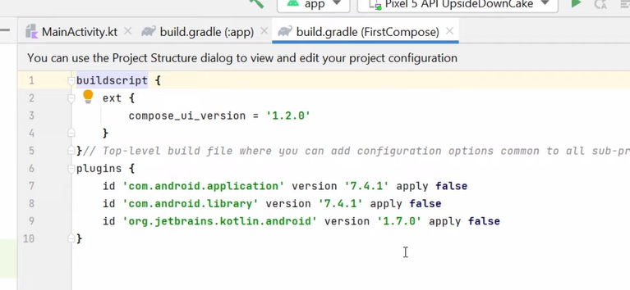

Kotlin ka version hai 1.7.0 to ye dono aaps mein connected hai aise hee nahi kuch bhi

This is our main act now

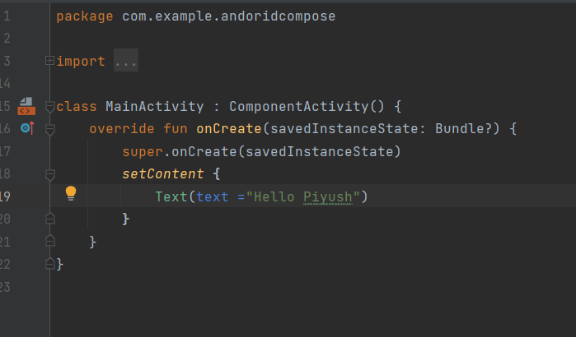

You can see we are esxtending ComponentAcctivty class vaise hum AppCompactAcvitity krte the

Uske baad setContent mein Text ek composable function hai uske andr likhdiya

Ab mein chahta hoon ke iska preview dikhe to hum ek preview function bnenge

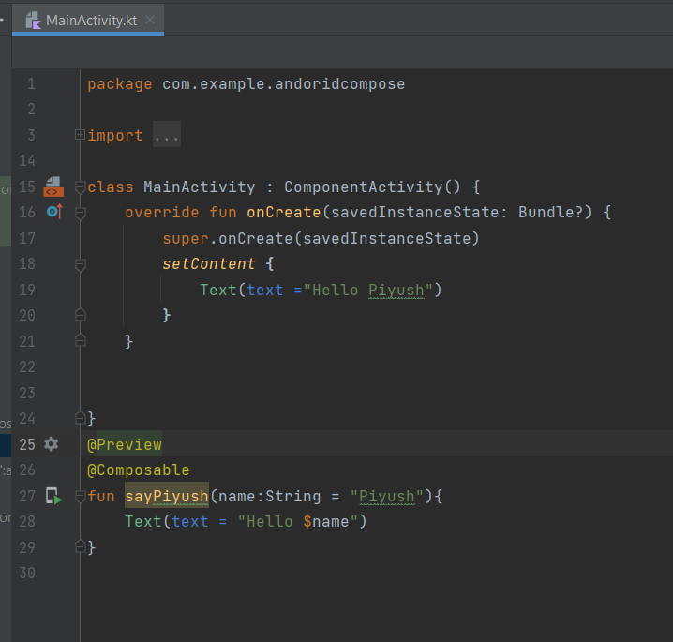

We wrote one function which is composable and then previewed it

This preview function has some parameters like showBackgroud it will show background around our method and it has name method if we want to see multiple composable At once we can distinguish

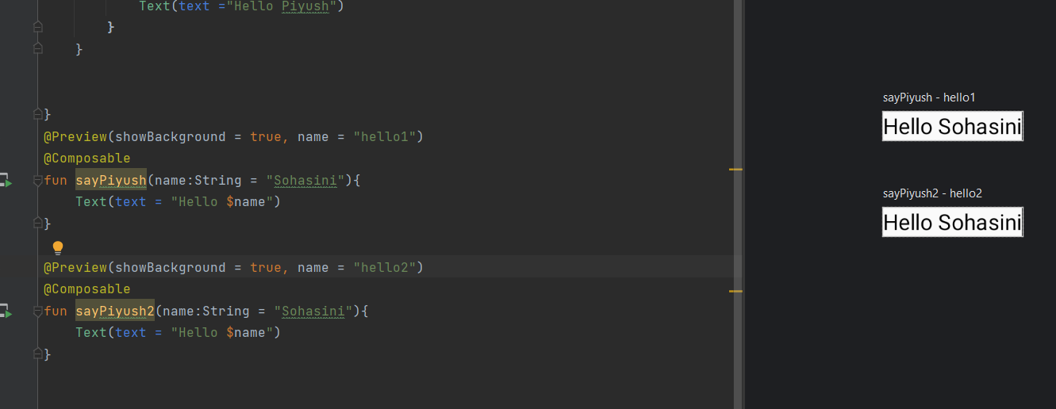

We can use different parameters like

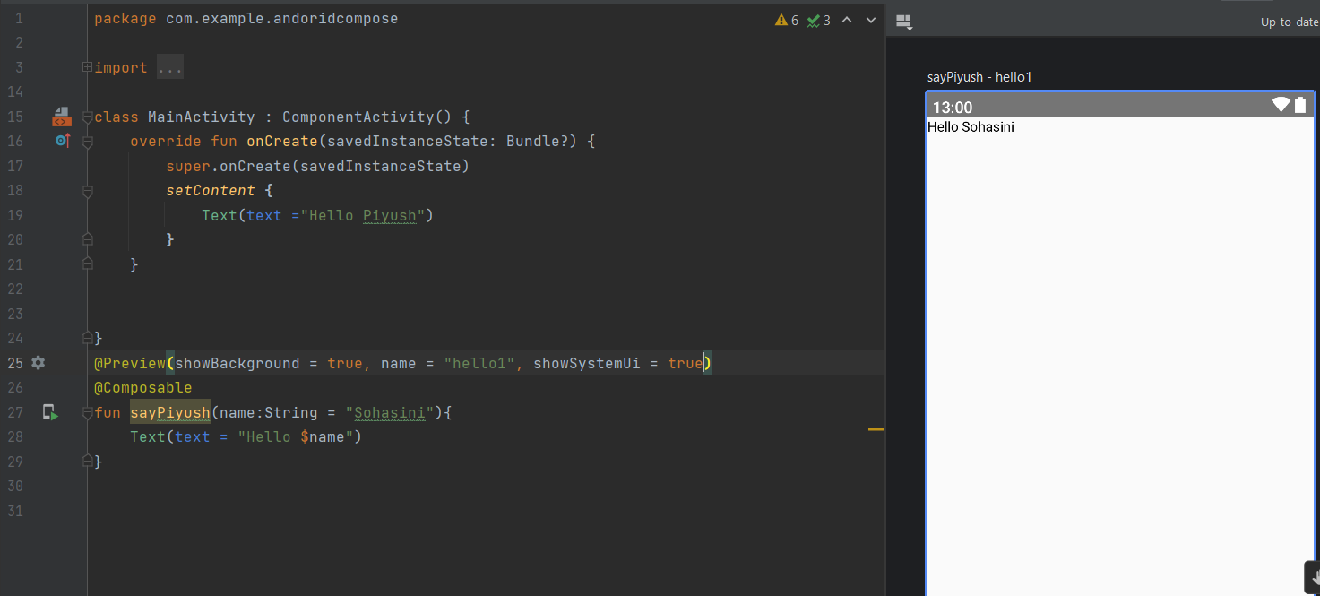

It will show like it shows on real device

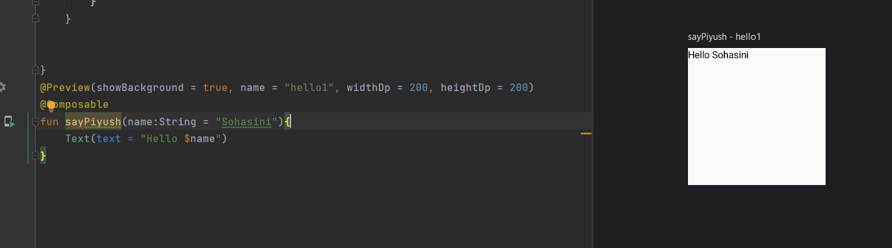

If we use width and height that will show with different width and height

If we remove the default value of saycheezy function it will give me an error



Then we can do somethinglike this

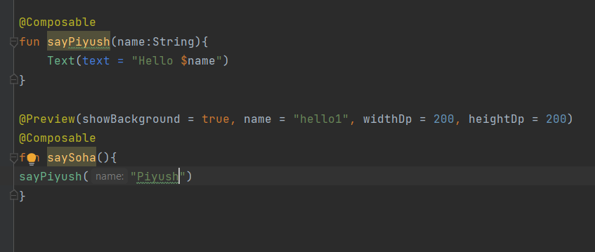

You can use different methods on composable functions like

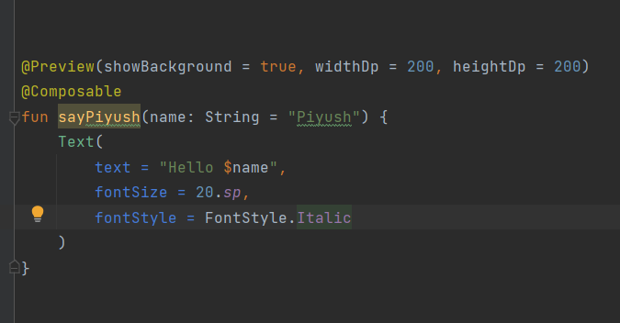

If you ctrl+click on Text it will show you all the functions

ImageComposable

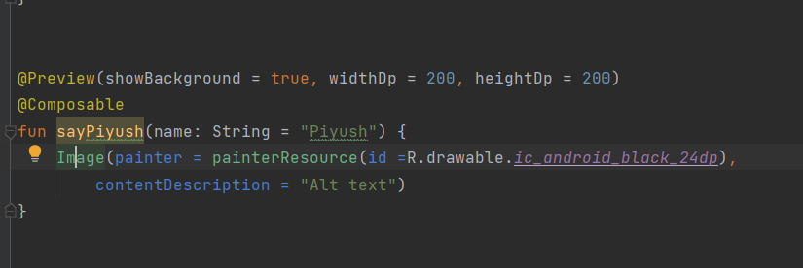

We have these methods in Image composable

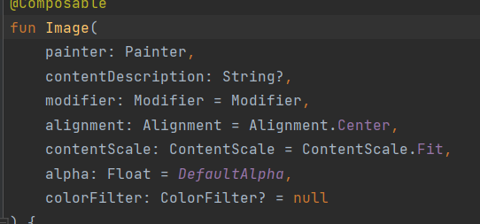

Button

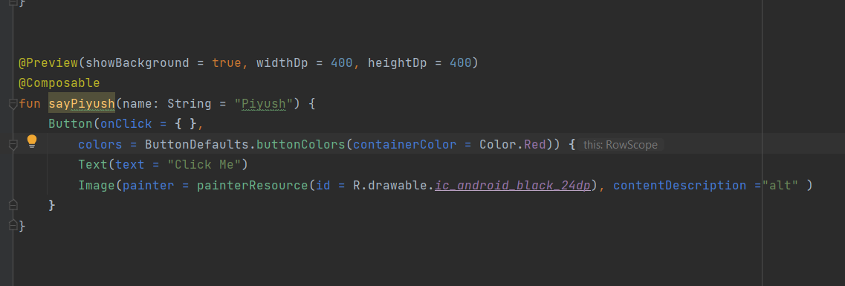

Aise he edittext kuch aise bnta hai

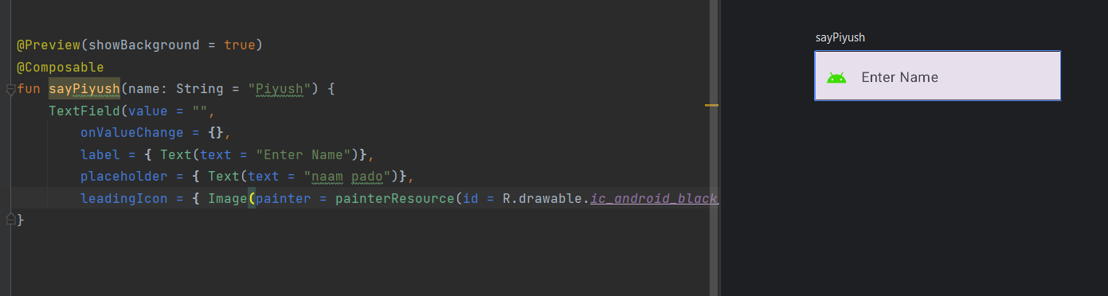

Ab compose mein kya hota hai sb kuch data ke hisaab se render hota hai jaise KI KISI bhi composable ko maine koi data diya agar vo data change hogya to ui dubara render krega

Jaise hee daqta mein update huya chahe vo button click ke event pe ya edit text pe composable function dubara call hoga or vo dubara UI ernder krega

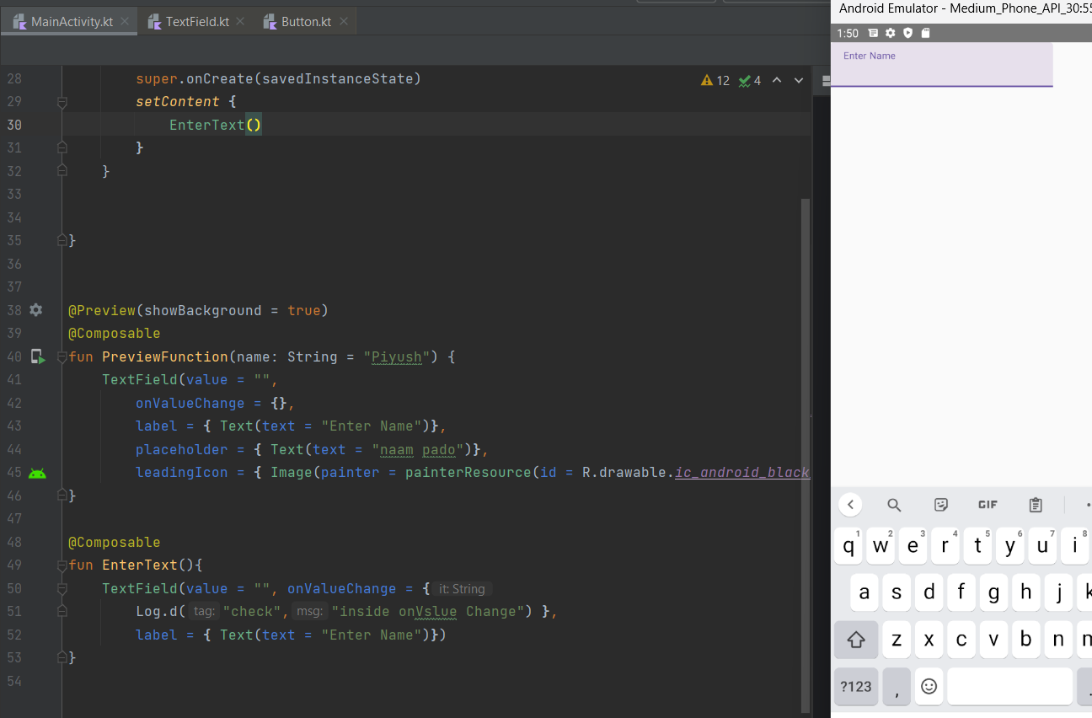

Abhib upr vali image ko smjhe to ismein ek enterText vala function hai jo run hoga appp pe or jb bhi mein kuch input likhta hoon edittext mein vo Log mein dikhata hai update value pr firse blank hojata hai kiuki hmne value uski blank rkhi hai

Ab isko solve krne ke liye hum ek variable bnaege jo ki jiski value agar change ho to ye function dubara call hoja evo update value se

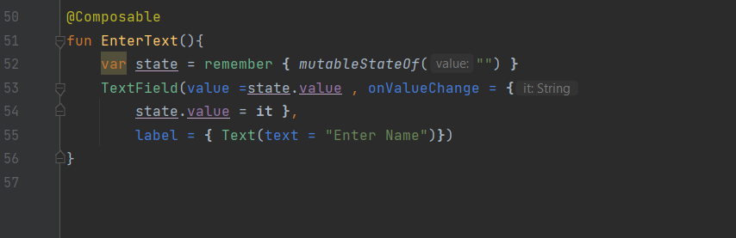



Aba upr humne pehle ek state bnaya state is any data that can change and we make our composables function like that when it changes and whenever our composabkle functions got called again it gets the update data

Remember:- iska matlab hai dekho pehle state variable ki value hai blank ab jb data change hoga to ye sara function again call hoga to 52 line dubara call hogi to vo to frse blank krdega isko hna to iske liye remember hmare liye uski last value rakhta hai

**Row, Column, Box**

Column

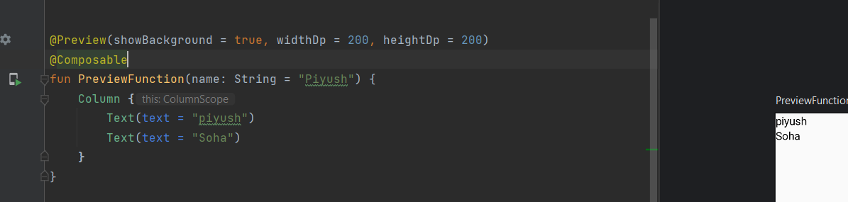

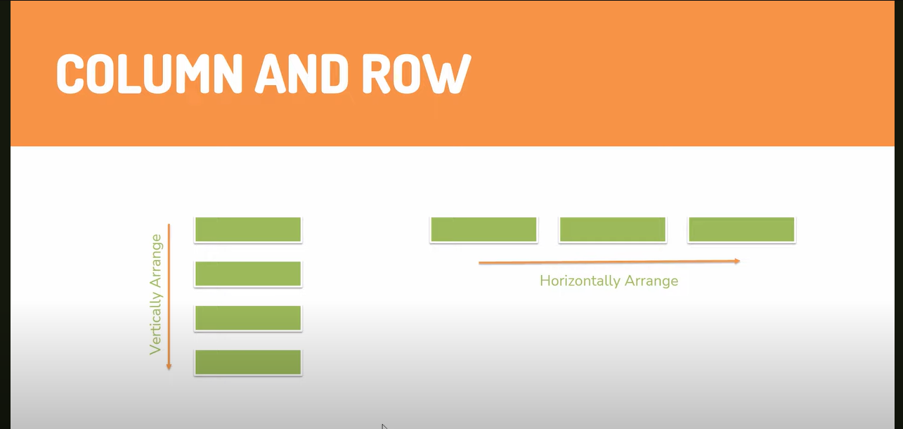

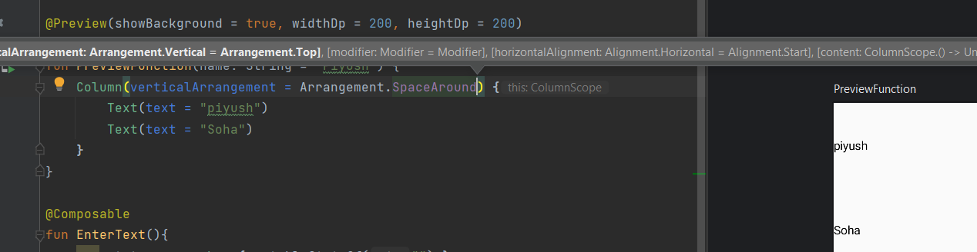

Ab ye column ki properties hai ke kaise dono ya jitni bhi cheeje hai unke beech mein kaisa arrangement hoga just like Flex property in CSS

Same ek horizontal ka bhi option hai

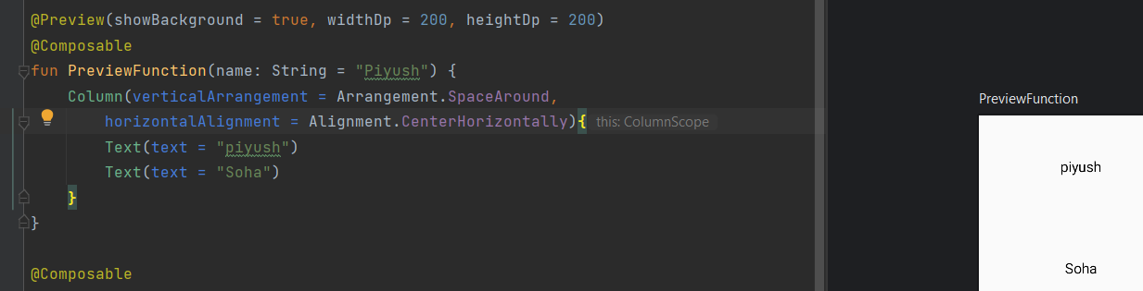

Same we have for Row as well

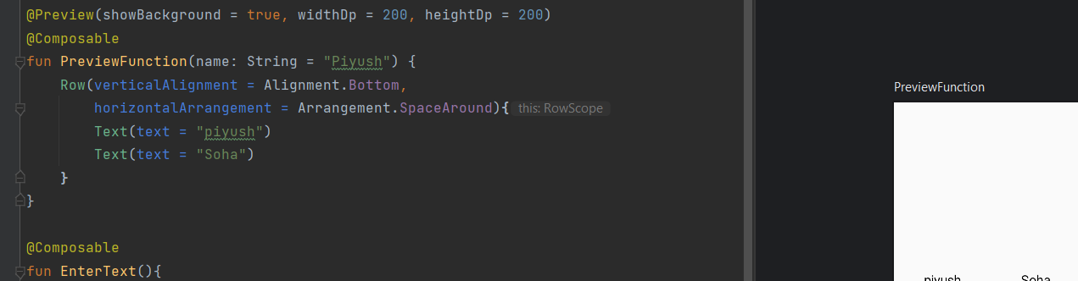

Similary we have Box composable as well

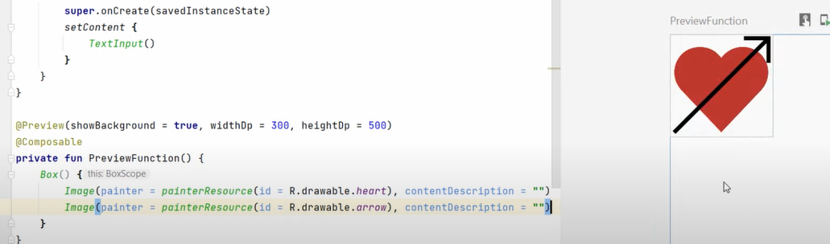

Ismein cheeje ek ke upr ek aati hai

Ye ek list bnake dekhi hai

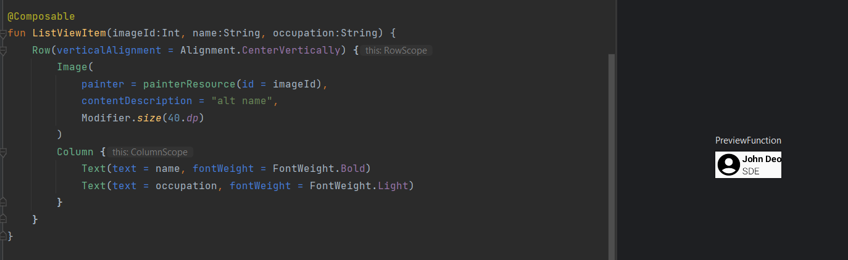

# Compose Modifiers

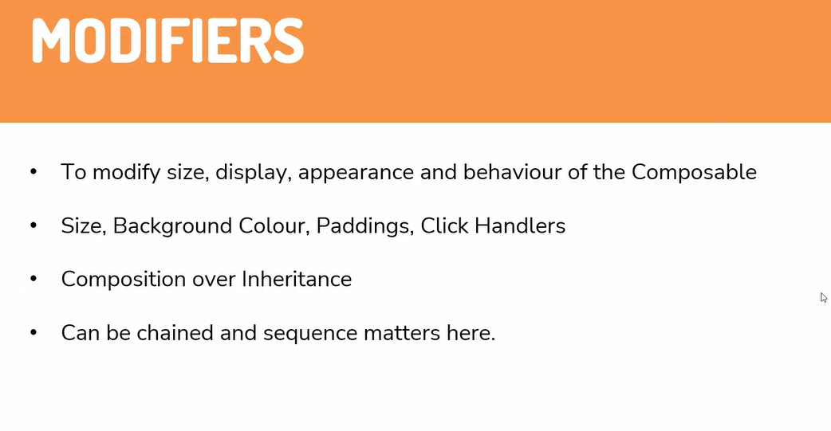

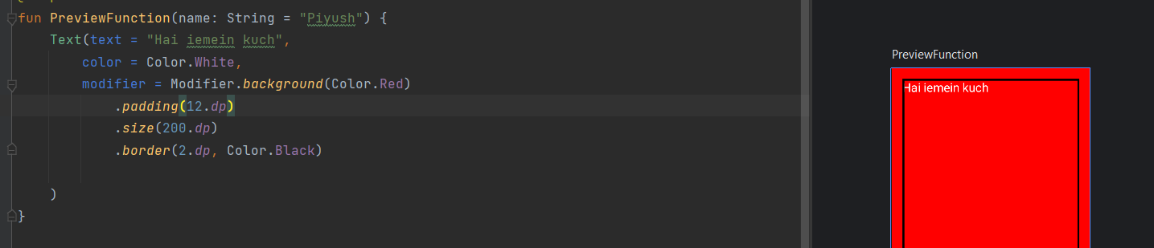

Similary we can make circular image as well

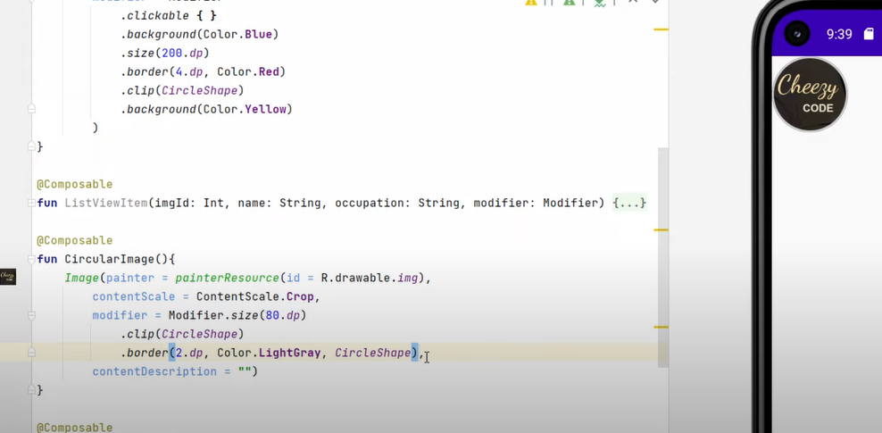

Let say humn ek functions bnae

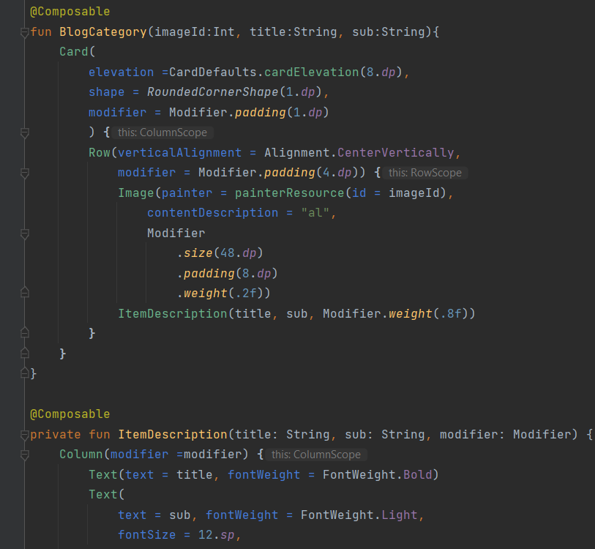

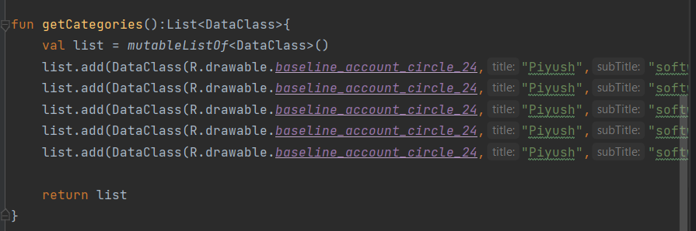

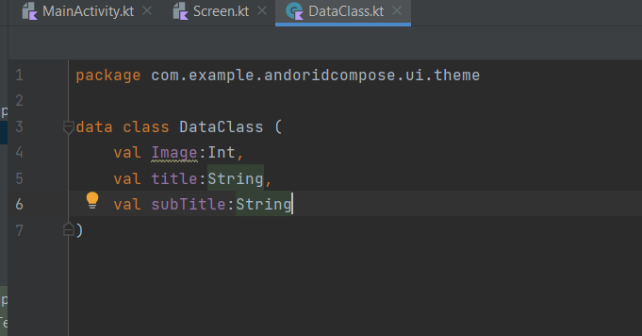

This is the output ab dekhte hai ki agar mein or items add krdu or preview ko height dedu dekhte hai scroll aara hai ke nai

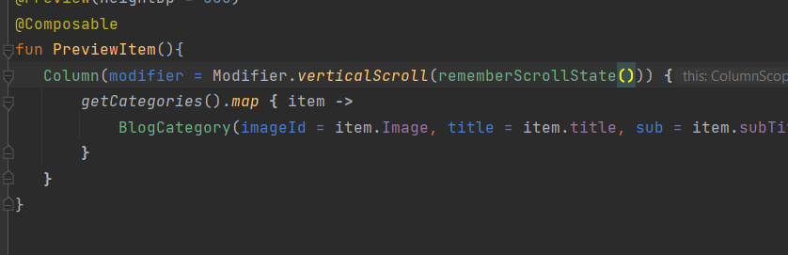by using above we can add scroll behaviour but iska ek drawback ye hai ke ye recyclerview ki trh views ko recycler nahi krega

To iska solution hai hmare pass lazycolumn

Uska mtlb hai jaise jaise items screen pe aati rhengi unko render krta rhega

# Compose Recomposition

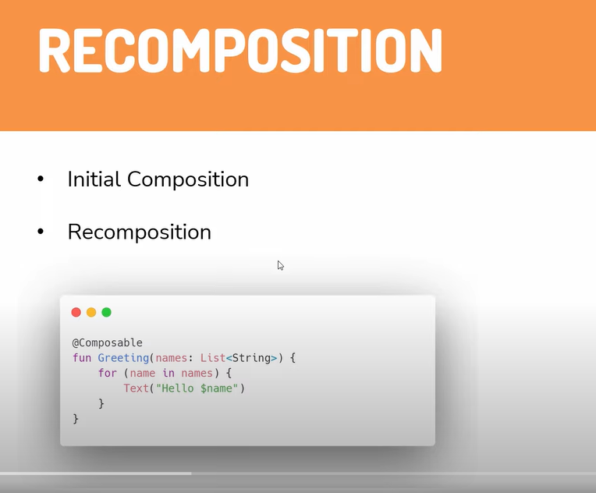initial composition matlab koi bhi composable function ko hum data denge or vo create krdega jb oehli baar create kra to intial composition jb data mein kuch change aaega tb dubara UI render hoga usko recomposition hoga

An socho agar ek big function mein change hai to jetpack poori screen ko dubara render krne lgega jiski vjh se performance issues honge uske liye hum

Composable functions ke andar heavy things ko nahi krna v

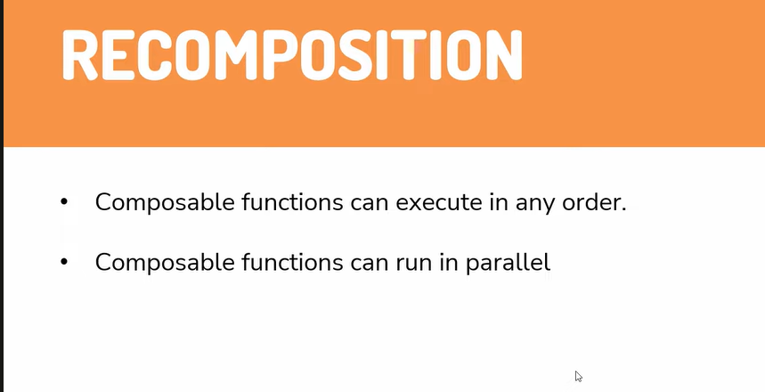

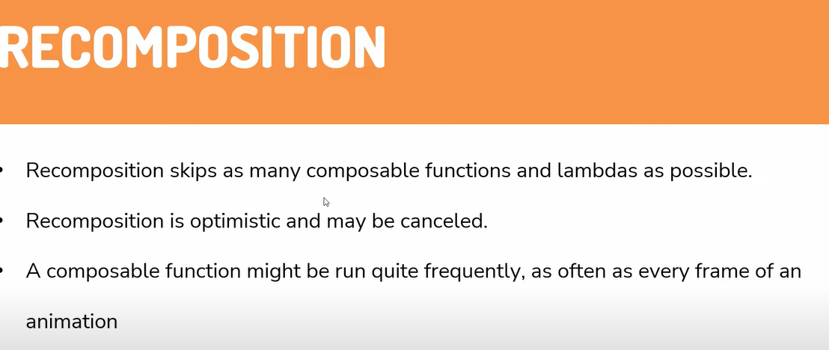

# Hoisting & Unidirectional Flow

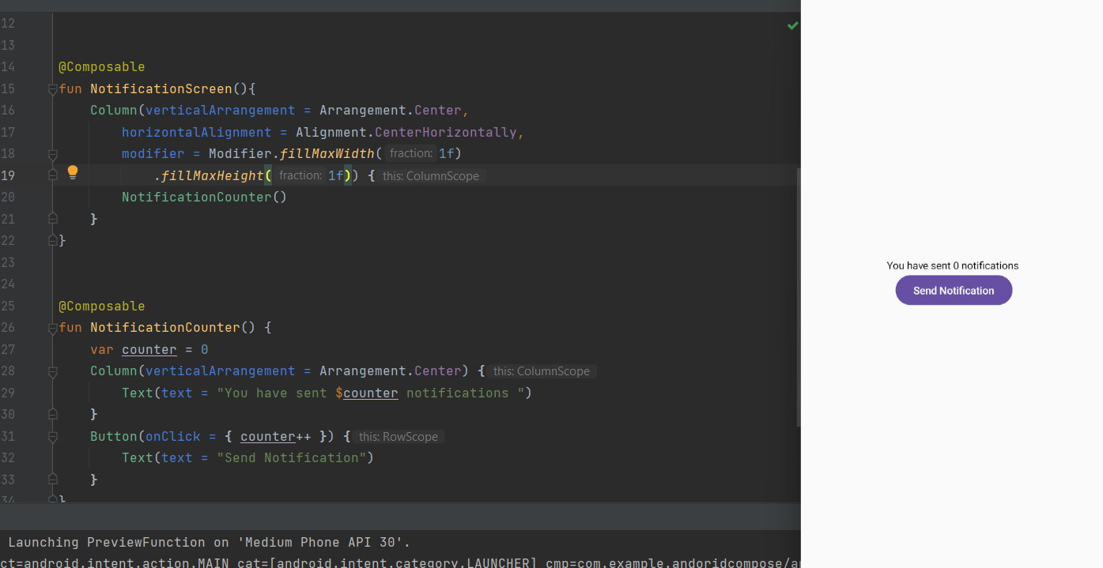

Ab is example mein mein button ko click kr rha hoon but kucjh ho nhi rha kiuki

Maine log lgake dekha to button click pe log statements to aai but counter ppklus nhi huya

Vohi state vala scene

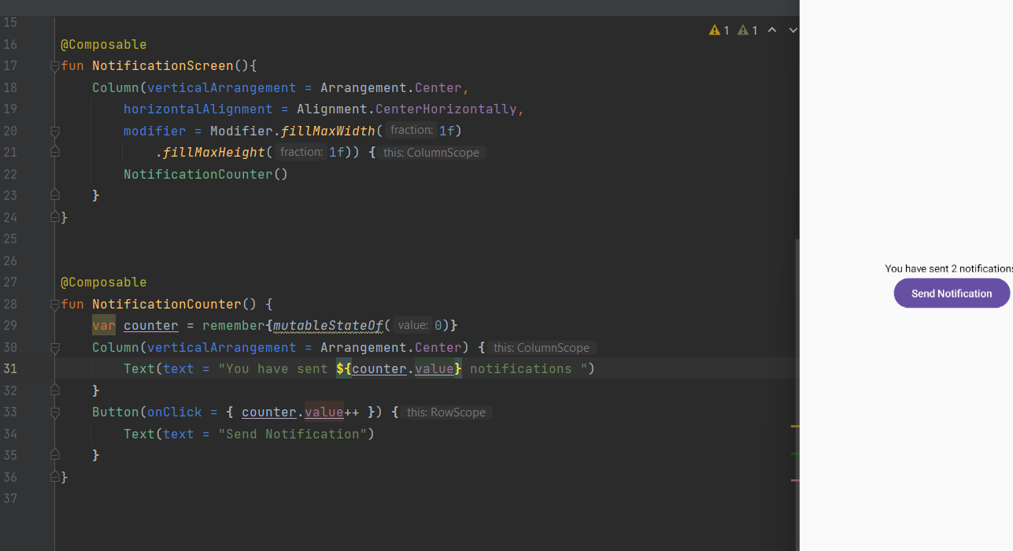

Pr isse chakkar ye huya ke phone rotate kiya to counter ki value 0 hogya kiuki activity create dubara se huyi uske liye ab aone ko bundle ko save krna hoga jo ki hum pehle krte the

Uske liye compose mein hai remember ki jgh rememberSaveable()

Ab ye hmare primitive data types hai jisko bundle mein save krdeta hai agar apne ko koi custom data ko krana hai to uske pehle parcelizer ka serialize krna hoga

Ab maine do cheeje bnai



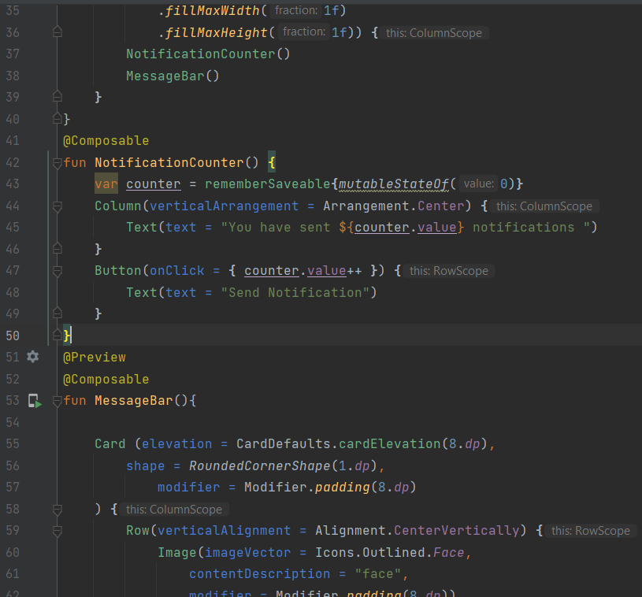

Ye do cheeje maine bnai hai ab mein chahta hoon agar mein button bdau to jo counter ki value message vale mein show ho

Ab apne ko apni jo state thi usko hoist krna prrega

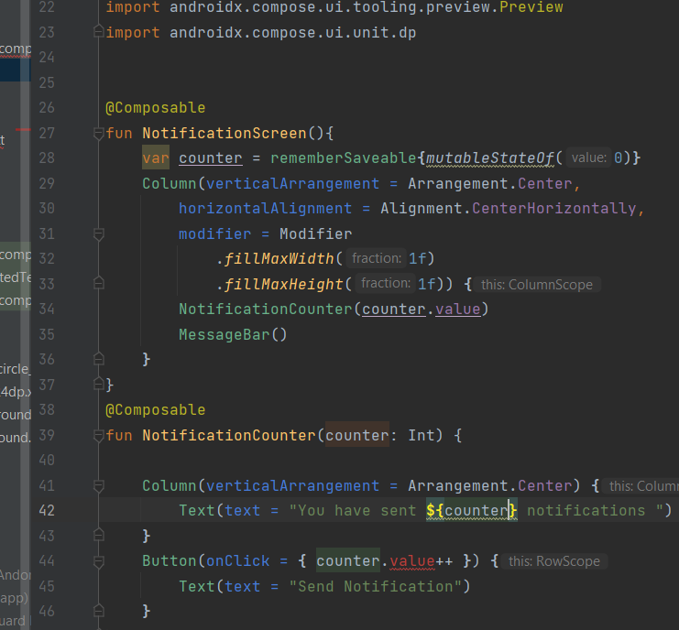

Ab dhyaan se dekho ab humne state ko hoist krdiya hai matlab jahan se hum apne compose ko call kr rhe hai vhana state ko rkha hai

Ab chakkar hai button click pe increment krne ka to uske liye hum lambda pass krenge

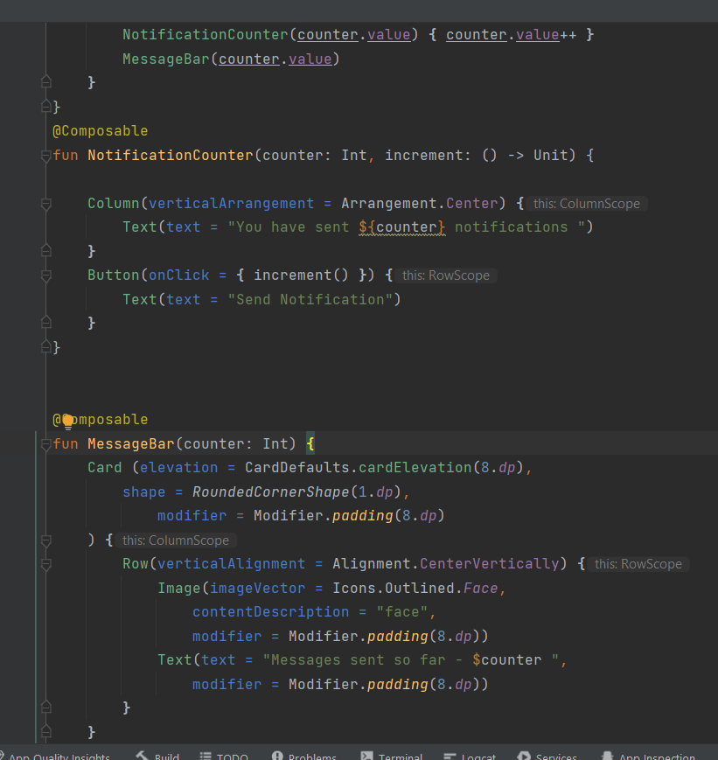

Ab in dono ka top vala function jidhr in dono ko call kra hai udhr state ka object bhi hai to jis composable function mein state hoe usko bolte hai statefull functions and jiske nahi unko bolte hai stateless functions

Unidirectional Flow:- iska matlab hota hai ki koi bhi data neeche ko flow krta hai or events upr ko

Note:-Read file from asset folder

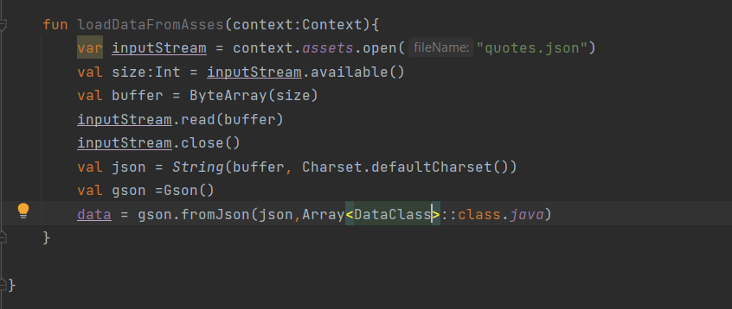

**Enum Classes**

**Lets say mera ek variable hai days naam ka mein chahta hoon usmein mein sirf days hee assign kr sku jaise ki Sunday, Monday etc. to hum bnate hai enum class**

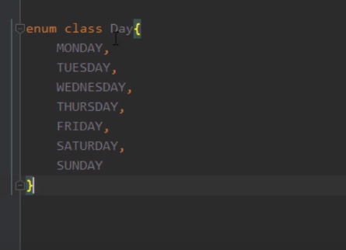

**Ye ek enum class hai ab ismein maine mondy jo likha hai ye is class ka instance hai similary Tuesday, Friday and so on bhi ek instance hai**

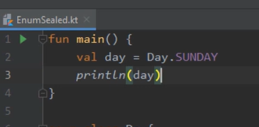

**To is treeke se hum ek class bnate hai or uske andar constants rkhte hai jo**

**Hum enumn class ka constructor bhi define kr ske hai**

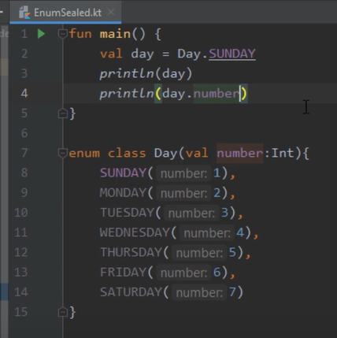

**We can use for loop for enum class**

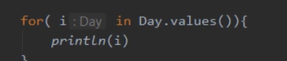

**We can also insert functions inside enum class**

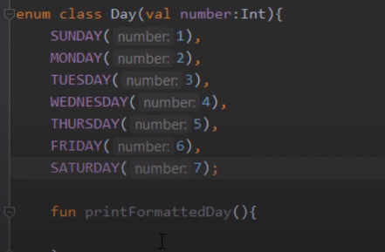

But make sure you add semicolon before adding a method

**Sealed Classes**

Enum class kya hota hai ke maine kuch value ka instance bnaya to usko hum baad mein change nhi kr skte ab mein chahta hoon jo instance maine bnaya uski state bhi change kru to uske liye sealed class

Side effects

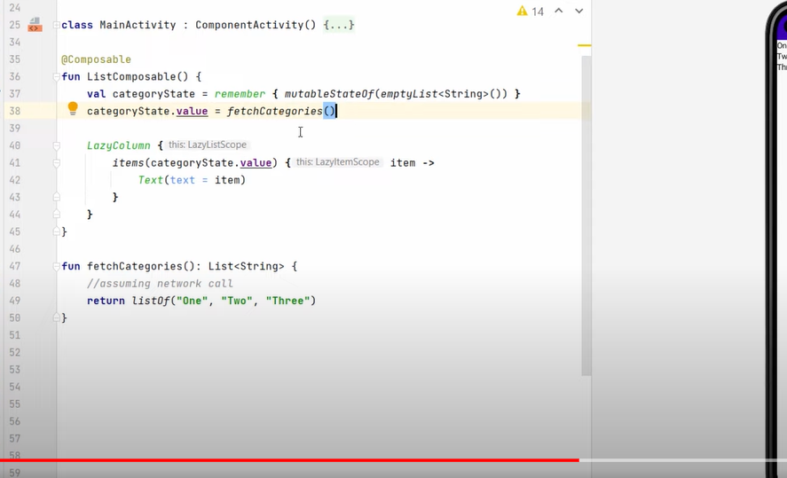

Kotlin hmein kehta hai ke hum composable mein aisa code nhi likhenge jo kibahr vali kisi cheej ko effect kr rha ho jaise ke yahan fetch vala code hmein nahi pta kitni bari run hoga kiuki vo recomposition bhi ho skti hai to upr vala code glt hai

Manage side effects

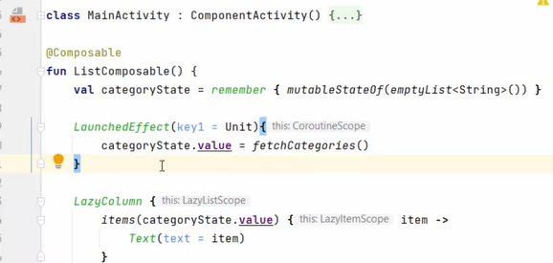

LaunchedEffectsf help krta hai hmari isko krne mein or ye jo key hai uska matlab hai jb jb key change hogi sirf tbhi ye blck of code run hoga nhi to nhi or iska fayda ye hai ke ye background thread oe run hota hia

Key mein koi bhi value pass kr skte hai false bhi pass kr skte hai jb bhui vo value change hogi sirf tbhi ye code chlega

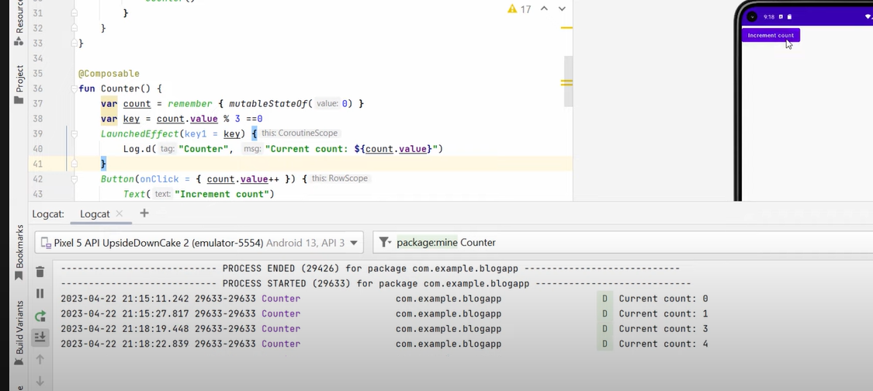

# Remember Coroutine Scope Example

We read about LaunchedEffect how it helps us to launch new coroutine but if we do configuration changes like screen rotate it will cancel that coroutine first then again start a new coroutine

Ab ismein ek problem hai ki jaise ye apnoe ko coroutine launch krta hai pr ab agar kisi event pe coroutine run krni ho to uspe hum isko nahi lga skte to uske liye

We can use rememberCoroutineScope

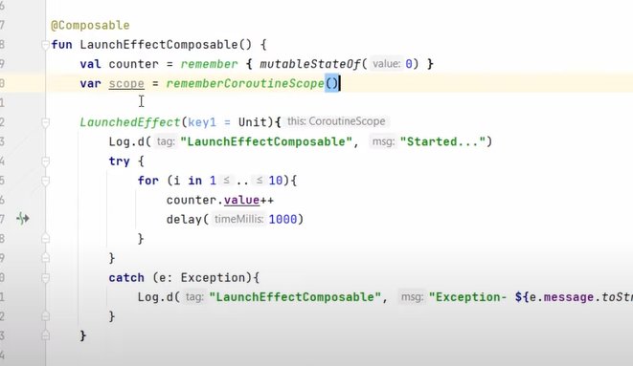

Ye iske andar ka code ekk different thread pe run krega

Ab ye hmne scope define kiya hai vo uske parent composable pe depend krta hai jb vo composable screen se htjaega to uske andar jitni bhi coroutines hongi vo bhi htjaengi

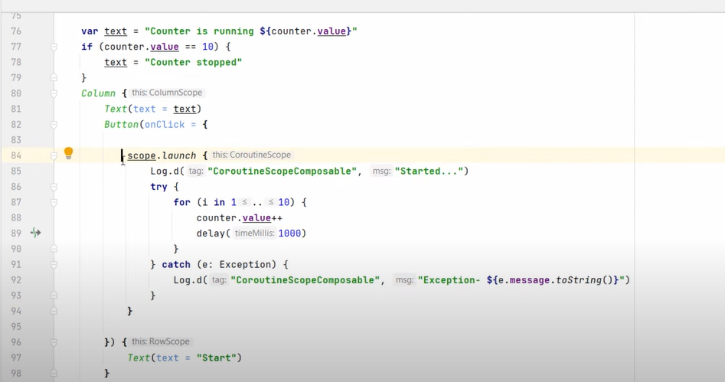

# RememberUpdatedState

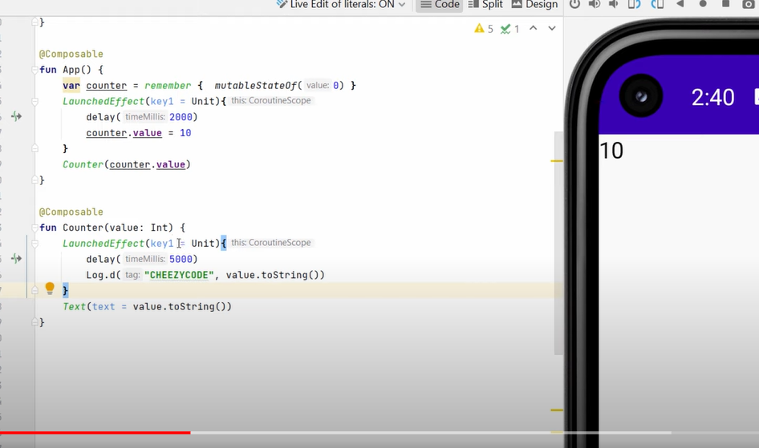

Ab is example ko hum agar dekhe screen pe to 10 aagya but logcat mein vo 0 hee aaya kiuki

Jb counter call huya tb uski value 0 thi tb tk Launchedeffect counter function vala call ho chuka tha pr fr recomposition hui to screen pe to 10 aagya but coutner ke andar launchedeffect vala nhi change huya kkiuki vo recomposition pe kaam nhi krta or vo different thread oe kaam krta hai or vo tb hee dubara call hota hai jb key ki value change ho

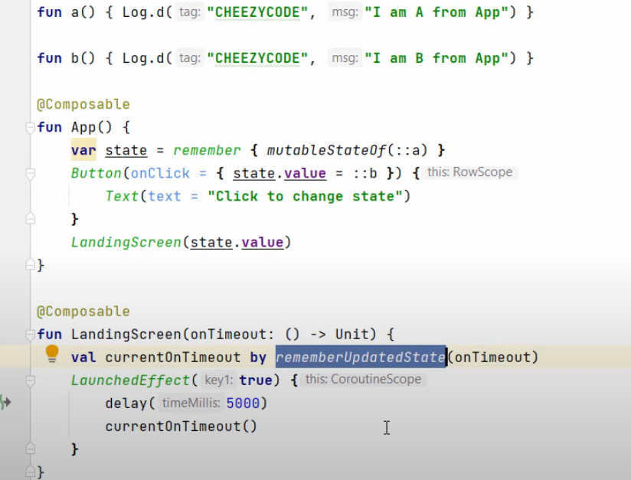

# Disposable Effect with Examples

Let say maine side effects ko handle krne ke liye kuch use kiye pr mein chahata hoon jb vo side effect screen se bahr chla gya to mein usko cleanup krna chaht hoon

Lets say maine apnme composable ke andar location service ko access kiya hai ab mein chahta hoon ki agar compose vo vala screen se bahr jae to location vala object ko mein dispose krdu

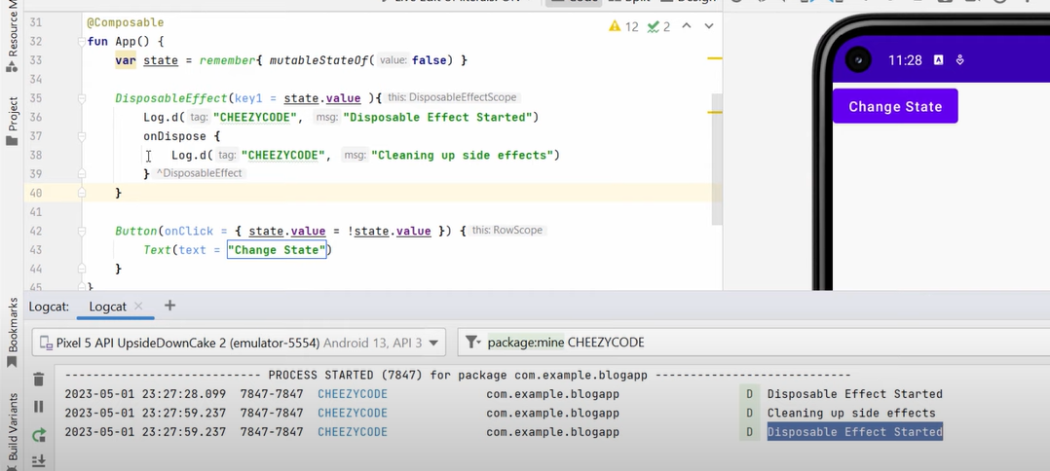

Another example

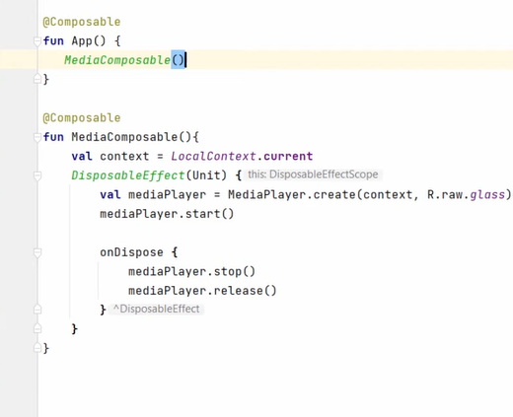

# produceState & derivedStateOf

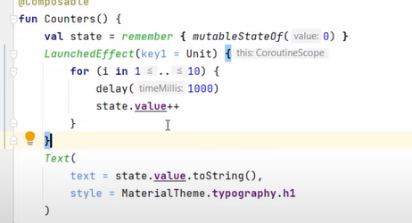

produceState:- ab upr code mein dekho maine ek state bnai or ek launchedeffect jo state ki value bdl rha hai do kaam kr rhe hai hum

uske liye produceState ek mein he kaam krdegi

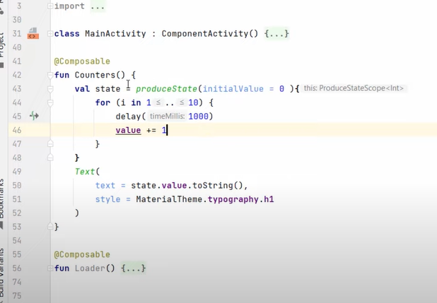

Derivedstate:- do tin state mein se ye state d=khud derive krta hai

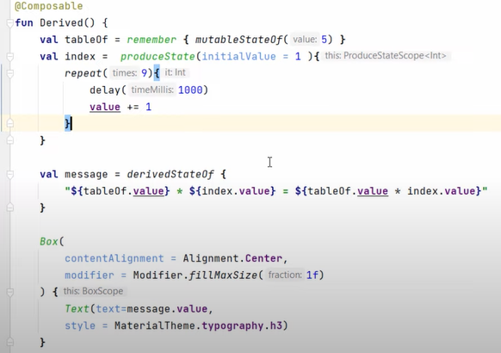

**Kotlin Flows**

Kotlin flow hum tab use krte hai jb server se hr baar data change hoke aarha hai

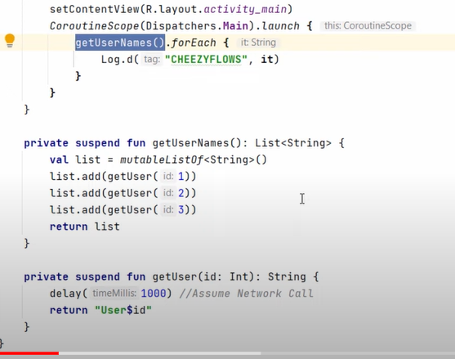

Ab idhr agar dekhe coroutine mein hmne ye code dala hai to jb ye list return krega fr hee hmara function for each chlaega or kaam krega tbtk free betha rhega

Hum chahte hai ki maine list mein add kiya ek cheej tb hee vo upr bhi log ho gyi aise he 2nd add hui log hogyi

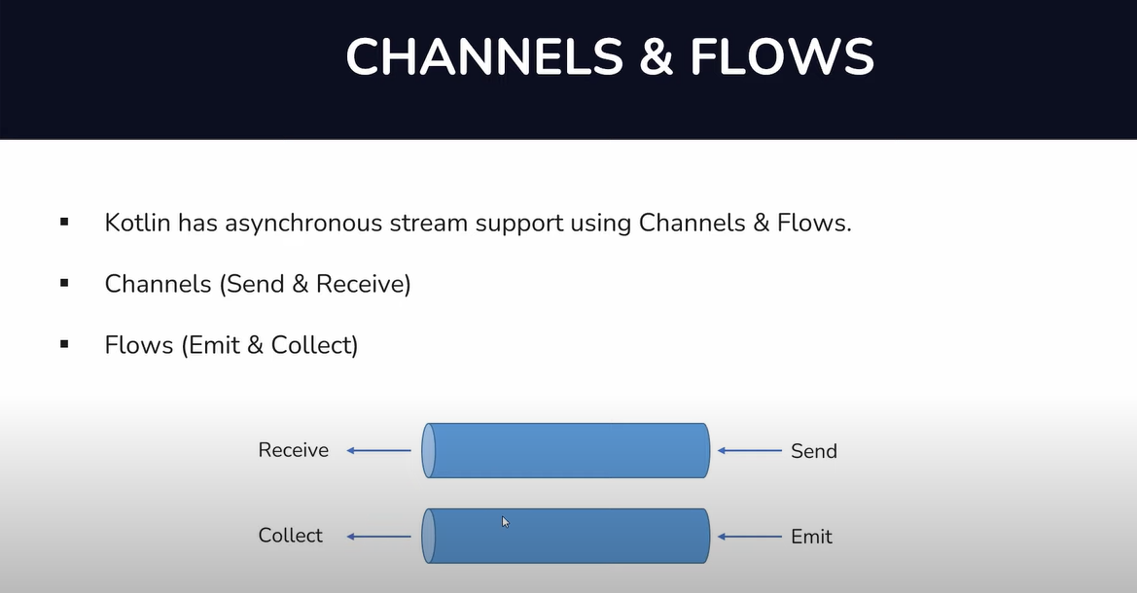



Hot matlab producer continuously data produce kr rhe honge chahe unhe koi consume kr rha hoy a nahi

Cold matlab producer sirf tb he data produce krega jb consumer hoga koi

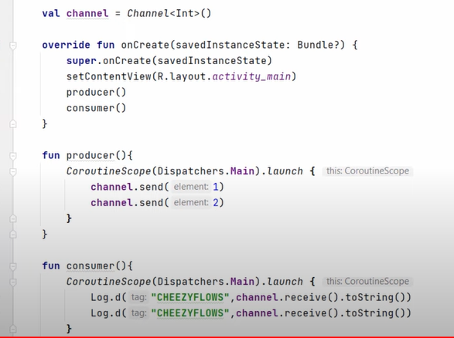



**Problem statement**

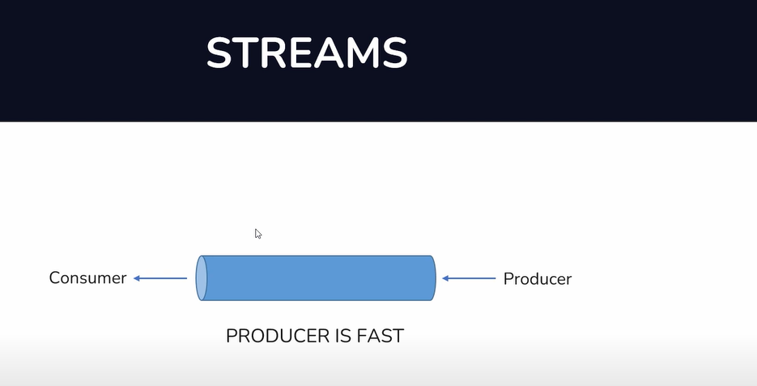

**Lets say producer hmara bhot fast data produce kr rha hai consumer consume nhi kr pa rha hai tb kya krenge**

**Tb hum buffering use krte hai**

**Android mein hum apni coroutine ko suspend krdete hai produce vali taki consumer oehle ashe se consume kr pae**

**Kotlin flow:-**

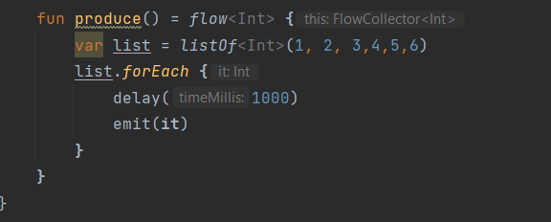

**Ye hmne ek producer bnaya jo ki stream mein emit function ki madad se data daal rha hai**

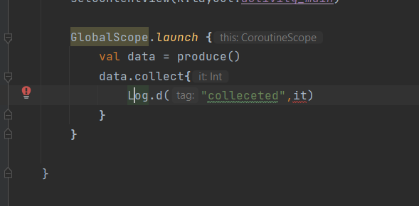

**Ye hmara consumer function hai data.collect**

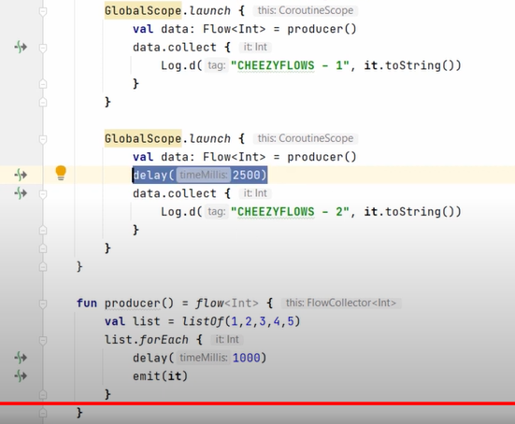

**Single producer multiple consumer**

**We have event in flows as well jaise on start or on complete**

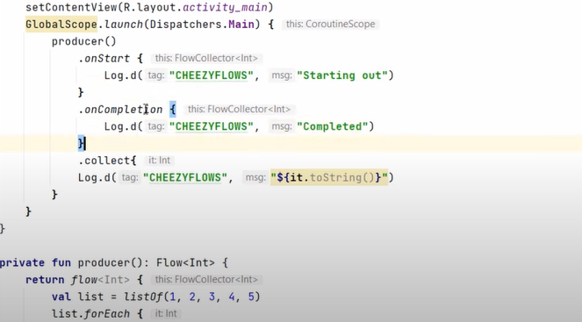

# Exception Handling

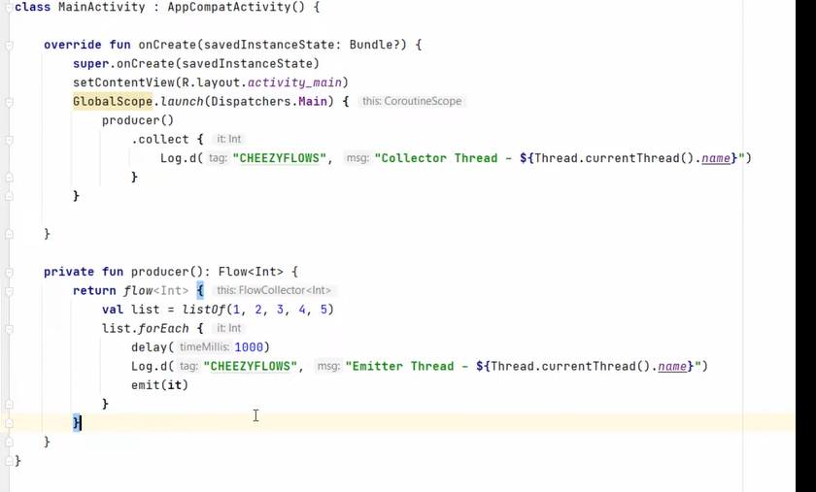

**Ab maine log mein dekha ke ji thread pr hum collect kr rhe hai usi pe produce kr rhe hai matlab is example mein hum main thread pe consume vala code likha hai to automatically produce vala code bhi main pe hee hoga**

**Ab I want ki mein collect to main thread pe kr sku but produce background thread oe kru**

**Use flowon**

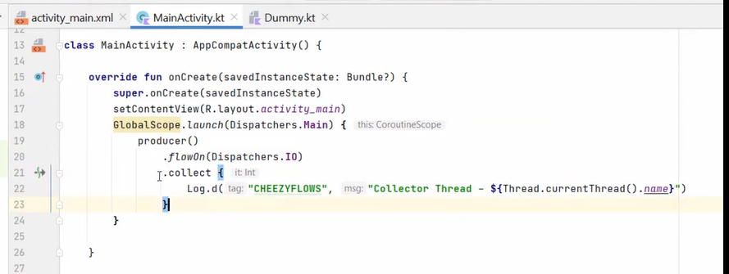

**Flowon works upstream**

**Exception**

**Use try catch and u can also use flow catch**

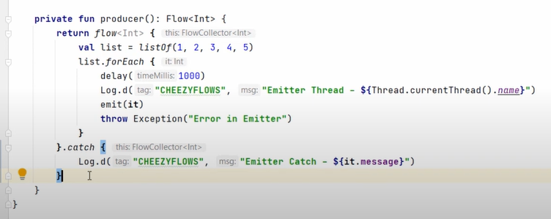

**Shred Flows**

**Abhi tk hmne dekha ke flows jo hai cold nature ke hote hai mtlb consumer hoga to hee producer produce krega**

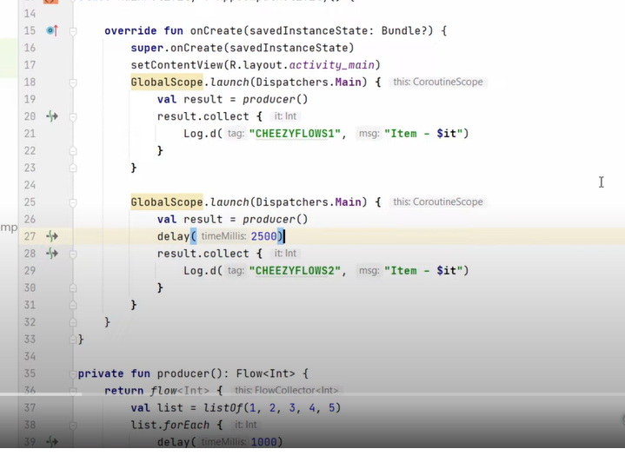

**Ab yahan pe pehle dono consumer ke pas data jaega as a stream to pehle ke pass jb 1 hoga doosra abhi delay mein hai fr after 2.5seconds second consumer bhi 1 se start hoga pr ab mein chahtan hoon ki dono ke consumer data share kre matlab consumer 1 ke pass 1 jae fr 2 jae fr consumer ke pass after 2.5sec baad 1 nhi 3 jae**

**Ab ye shared flow jo hote hai vo hot ke hote hai**

**So do treeke hai bnane ke ek to hai mutableSharedFlow ek hai SharedFlow**

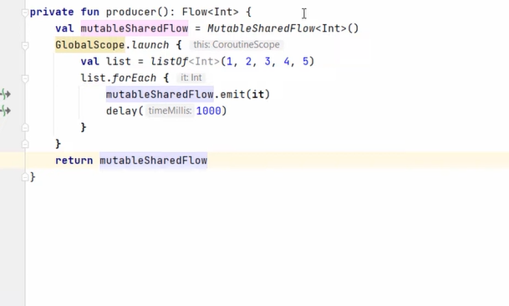

**Replay is the value ki manlo koi doosra flow hai to usko mein chahta hoon kuch time tk values agar vo misss kr jae to vo puran ni values bhi le ske abi yahan hmne 1 pass kra hai matlab 1 purani value ye store krke rkhega**

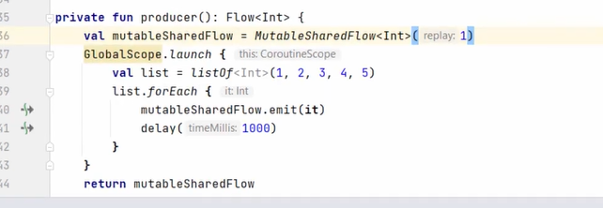



# StateFlow vs LiveData vs SharedFlow

**Stateflow bhi sharedflow he hai difference ye hai ke stateflow state maintain krke rkhta hai matlab jo bhi flow ki last value hogi vo isko save krke rkhta hai**

# Jetpack Compose Navigation with Nav Arguments

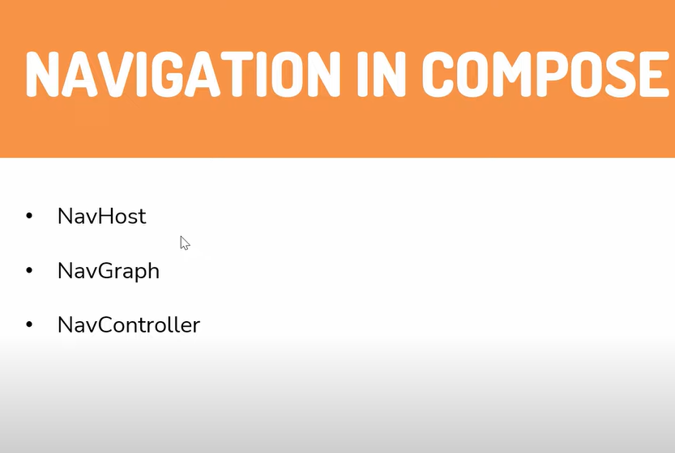

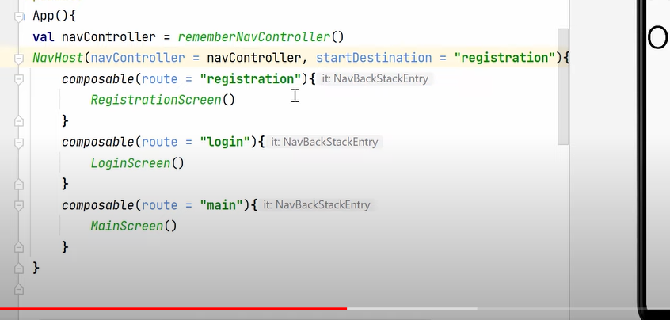**ab mein RegistrationScreen(navController)**

**Daldiya**

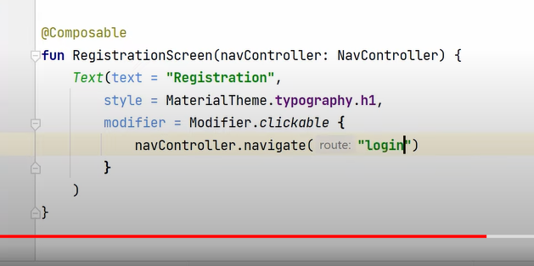

**Doosra treeka hai ke jaise instead of passing whole navController hum ek function pass krdete hai**

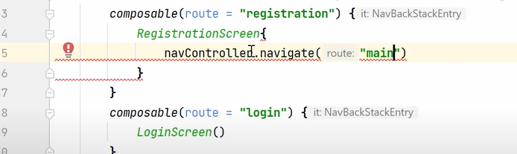

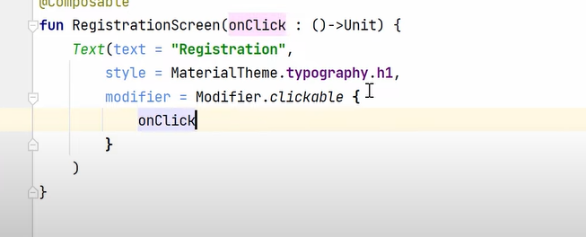

**Jb bhi argument send krne hai to**

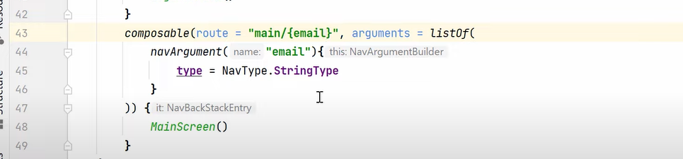

**Or compose mein jake**

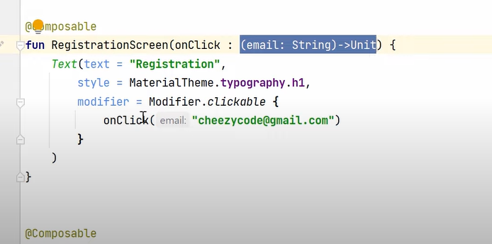**jb hum itna krdenge to route vale code mein aajaega change**

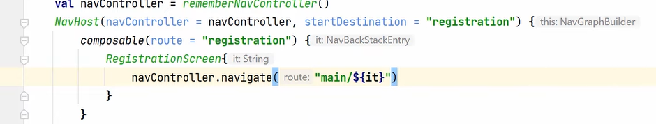

**Aise jahan lena hai argument neeche ke hisab se likhenge**

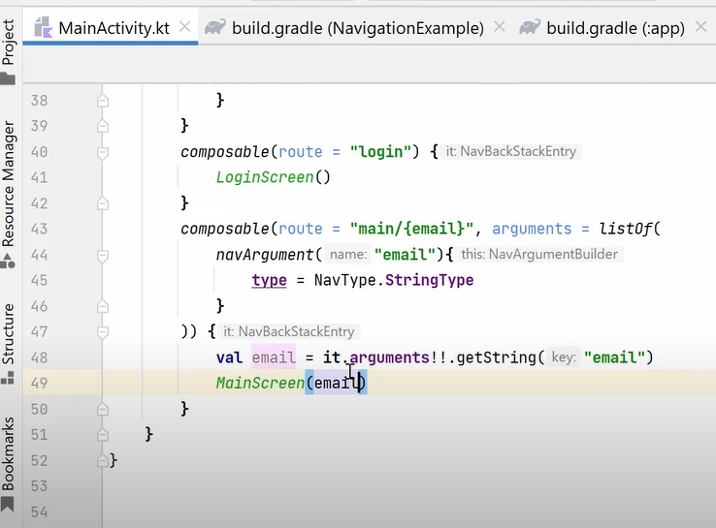

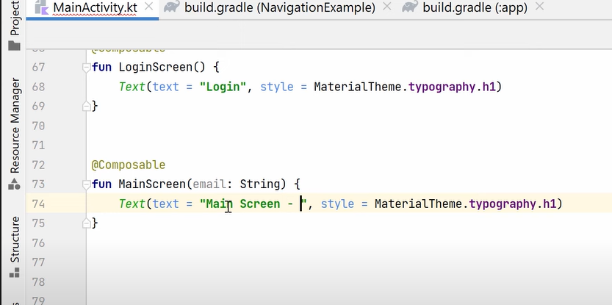

**Jb bhi hum ek screen se doosri screen pr jate hai to hmare argument ek or jgh save hote hai**

